MATHS QUESTION BANK CLASS 4
TERM II
Q1) TICK THE CORRECT ANSWER:
Q1. Assertion (A): Every Diameter is a chord.
Reason(R): A diameter is the longest chord of a circle.
- Both (A) and (R) are True and (R) is the correct explanation of (A).
- Both (A) and (R) are True and (R) is not correct explanation of (A).
- (A) is True but (R) is False.
- (A) is False but (R) is True.
Q2. Assertion (A): A shape can be symmetrical if one half of the shape appears to be a reflection of the other half.
Reason(R): If the shape is folded half over the line of symmetry the two halves are not each other’s mirror images.
A) Both (A) and (R) are True and (R) is the correct explanation of (A).
B) Both (A) and (R) are True and (R) is not correct explanation of (A).
C) (A) is True but (R) is False.
D) (A) is False but (R) is True.

Q3. Assertion (A): An equilateral triangle has three liens of symmetry.
Reason(R): The parts of the triangle on either side of a line of symmetry are mirror images of each other.
A) Both (A) and (R) are True and (R) is the correct explanation of (A).
B) Both (A) and (R) are True and (R) is not correct explanation of (A).
C) (A) is True but (R) is False.
D) (A) is False but (R) is True.

Q4. The line segment where two faces of a solid object meet is called an ……………
A) Face B) Edge C) Vertex D) Corner

Q5. The polygon having six sides is called a _____________.
A) Triangle B) Rectangle C) Pentagon D) Hexagon

Q6. The area of the Square and rectangle are equal. Length of the side of the square is 8 cm. find the length of the rectangle if the breadth is 4 cm.
A) 10 B) 8 C) 16 D) 12

Q7. 4:45 pm when converted into 24 hours clock time is equal to________.
A) 1645h B) 1445h C) 0445h D) 1745h

Q8. 3 days and one fourth a day is equal to how many hours?
A) 62 hours B) 16 hours C) 78 hours D) 82 hours

Q9. The cost of one toy car is Rs. 80.75. What will be the cost of 12 such toy cars?
A) Rs. 969 B) Rs. 1200 C) Rs. 678 D) Rs. 900

Q10. Total cost ÷ Total number of items = ___________
A) Cost of one item B) Grand Total C) Unit cost D) Quantity

Q11. What is the product of an even number and an odd number?
A) Odd B) Even C) Zero D) cannot be determined

Q12. How would you describe this pattern rule?
4, 11, 18, 25, 32, 39,
- Subtract 8 B) Subtract 3 C) Multiply 6 D) Add 7

Q13. In a certain code, CHAIR is coded as 24685, Rent is coded as 5137,
how is REAR coded?
A) 4474 B) 5165 C) 8257 D) 6412

Q 14.Which of the following can you learn from a bar graph?
A) The exact values of the data B) the trends over time
C) The relationship between different variables D) all of the above

Q15. Students of different classes in a school took part in fancy dress competition. The following bar graph shows us how many students participated from each class. Answer the following questions.

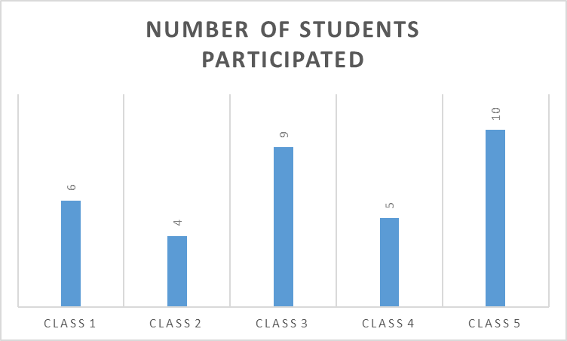

- From which class least number of students participated?
- Class 5 B) Class 2 C) Class 1
- From Which Class Maximum Number of students participated?
- Class 5 B) Class 1 C) Class 4
- How many total participants were there in the competition?
- 24 B) 34 C) 30

CHP 11.GEOMETRY
Q2. Solve the following 2 marks

1 | A gardener measures 12 m from the center of a circular garden to the edge. What is the total width of the garden through its center, which is also the longest chord?
2. | A clockmaker measures 9 inches from the center of a round clock face to the edge. What is the total width of the clock face through its center, which is the longest chord?
3. | a)Find the diameter of the circle whose radius is 7cm.  b) Find the radius of the circle whose diameter is 16cm
Q3 | Solve the following: | 3 marks
1. | Identify the tessellates and non tessellates from the following:-  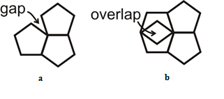  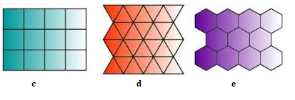
2. | Identify polygons, closed curves and open curves from the following:  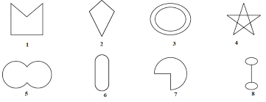
3. | a) Draw a line segment of length 4.5 cm.  b)Draw a circle with radius 4cm.Label as centre O,chord AB, diameter XY
Q4. | Case study  Rahul, a 4th-grade student, was playing with alphabet blocks. He noticed that some letters looked the same when reflected in a mirror, while others looked different. Curious, he took a piece of paper and drew the capital letters from A to Z. Then, he folded the paper along the vertical or horizontal axis to check which letters had symmetry.  He observed that some letters had a vertical line of symmetry, some had a horizontal line of symmetry, and a few had both.  - Which letters have only vertical line of symmetry?  - Which letters have no line of symmetry?  - Which letters have both lines of symmetry
Chapter 12:AREA AND PERIMETER
Q2 | Solve the following
1. | Find the perimeter of the following  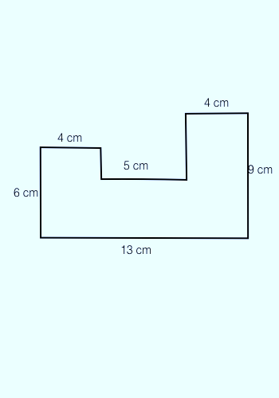  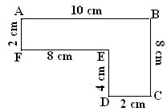  - (b)
2. | a)Find the perimeter of an equilateral triangle with side 14cm.  b)Find the perimeter of a regular pentagon with side 17m.
3. | The perimeter of a rectangular garden is 60 m.If its breadth is 10 m ,find its length.
Q3 | Solve the following:
1. | a)Find the area of the given shape 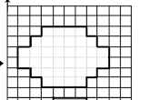by counting the squares.  b)Find the area of a rectangular room which has sides27m and 18m?
2. | a) Find the side of a square whose area is 36 sqcm.  b) Find the area of a square whose side is 19 cm.
Q4 | Case study  Riya and Aarav are helping their mother arrange a carpet in their living room. The carpet is rectangular, and they need to check if it will fit properly. The length of the carpet is 8 metres, and the width is 5 metres.  - What is the area of the rectangular carpet?  - If the cost of carpeting is ₹50 per square metre, what is the total cost for covering the rectangular carpet?
CHAPTER 13:TIME
Q2. | Solve the following
1. | 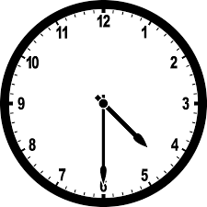  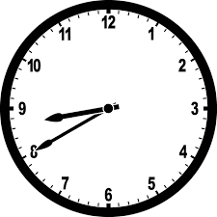 It is pm in the clock, convert into 24-hour clock.
2. | Convert the given time into 12-hour clock  - 2235 hours b) 1530 hours
3. | Rohan is preparing for his upcoming math exam. He studies for 500 minutes in total over a few days. How many hours and minutes he has studied in total.
Q3 | Solve the following
1. | a)Ravi is participating in a school running competition. He completes his race in 3 minutes and 15 seconds. To compare his time with other runners, the coach asks him to convert his total race time into seconds. Find the total seconds used by Ravi.  b) Riya is planning a road trip and calculates that the total travel time will be 5,760 minutes. To better plan her stops, she needs to convert this time into hours.
2. | a)Rajesh goes to bed at 9:30pm and wakes up at 6:40am .How long does he sleep?  b) How many minutes have passed from 7:20am to 8:45am.
Q4 | Case study  Amit is traveling by train to his hometown. According to the schedule, his train was supposed to arrive at 8:20 AM. However, due to unexpected delays, the train is running three-fourths of a day late.  Now, Amit wants to calculate the new arrival time so he can inform his family.  - How many hours is three-fourths of a day?  - If Amit's train was originally scheduled to arrive at 8:20 AM, what will be the new arrival time after the delay?

